JAVA ASSIGNMENT

K ADITHYA SAKETH

MICROSERVICES BATCH 1 (MIDDLE TIER)

Q.WAP to find whether the no entered by user is even or odd.

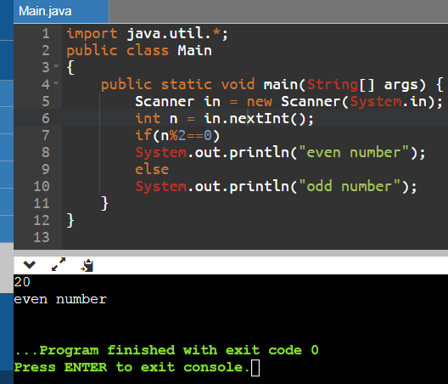

Q.WAP to swap the values of 2 nos.(Take input from user)

eg a=10 b=20

after swapping

a=20 b=10

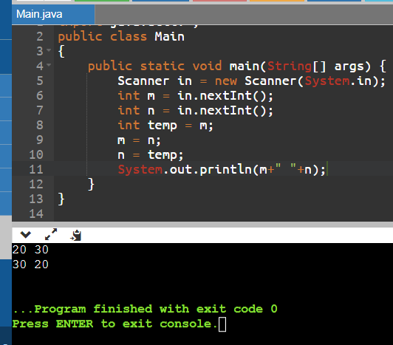

1. WAP to find the greatest between the 3 nos and display the output. (Take input from user)

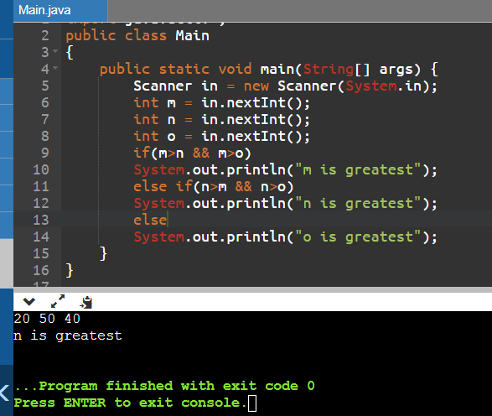

Q.WAP to find weather the character entered by user is a vowel or not.(solve by using if..else and switch case)

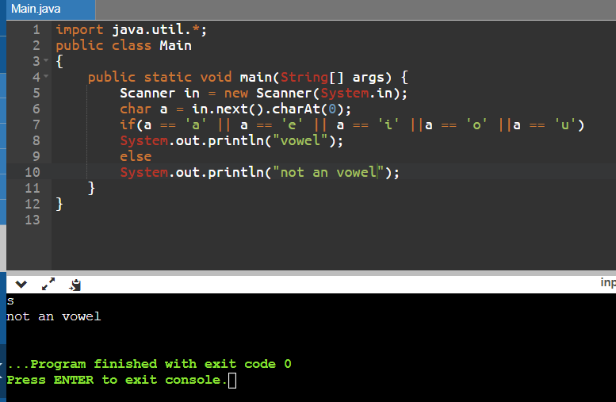

Using switch case:

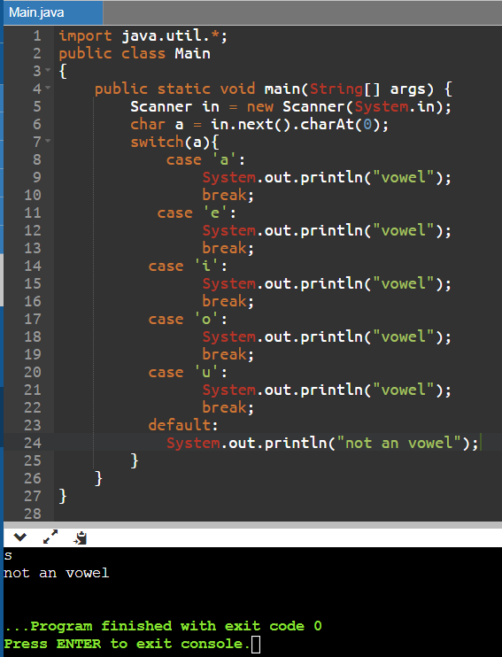

Q.WAP to print even nos from 1-50 using while loop.

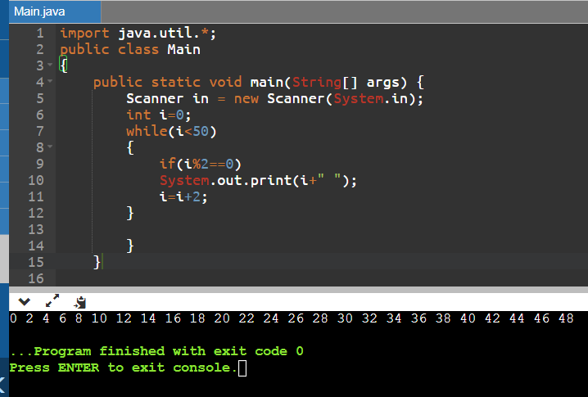

R.WAP to print odd nos from 50-100 using do while loop.

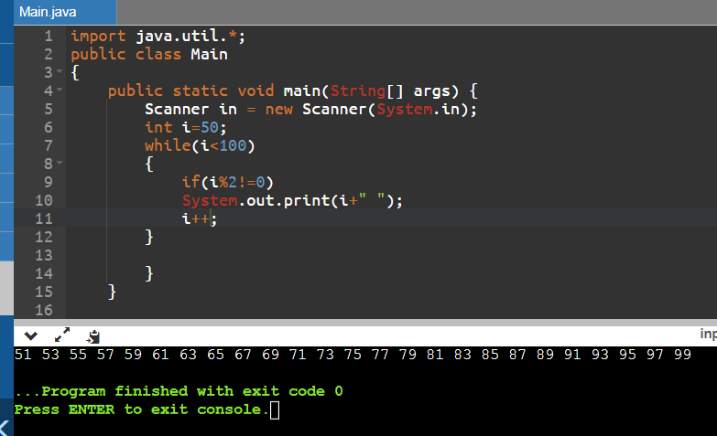

Q.Given a number N, print sum of all even numbers from 1 to N.

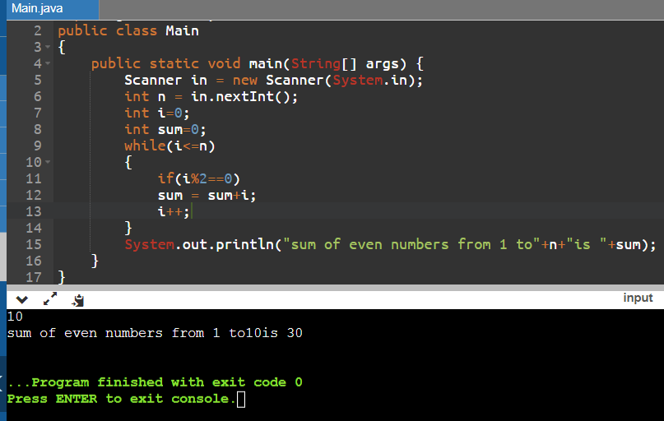

Q. WAP to print the following patterns

a.for n=4

1

22

333

4444

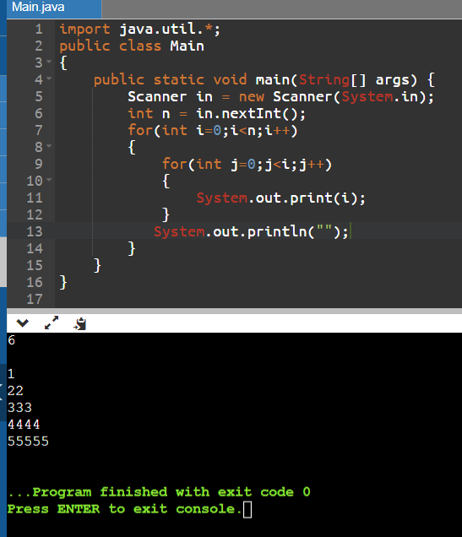

b.for n=4

4444

4444

4444

4444

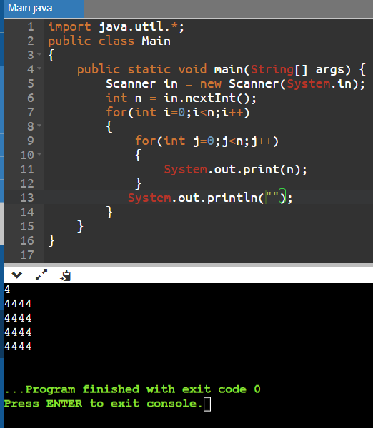

c.for n=5

\*

\*\*

\*\*\*

\*\*\*\*

\*\*\*\*\*

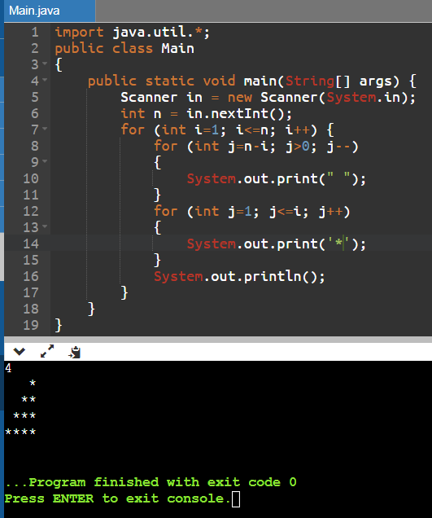

1. Revers an Array.

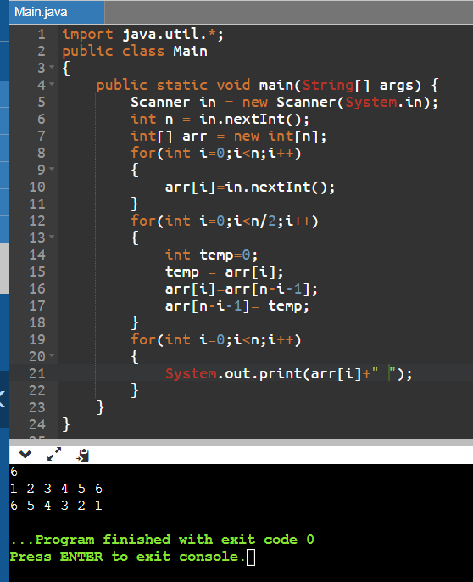

1. Swap the nos in Array.



1. WAP to calculate and display the factorial of a no entered by user.

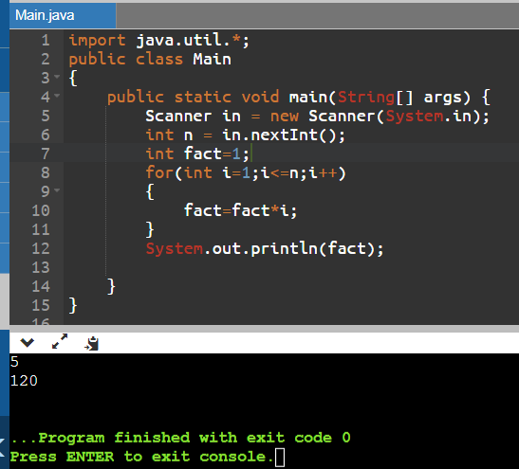

1. WAP to check weather the no entered by user is prime or not.

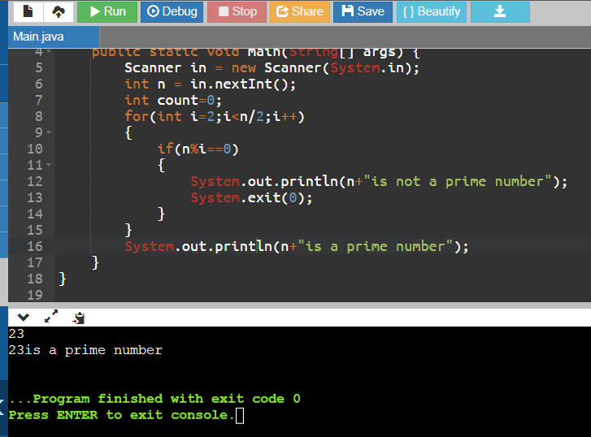

Given an integer N, print all the prime numbers that lie in the range 2 to N (both inclusive).

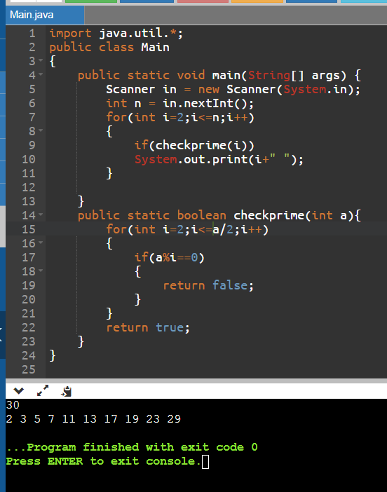

Q.WAP to generate the reverse of a given number N. Print the corresponding reverse number.

